G VENKATA SRIDHAR  gvsridhar.devops@gmail.com
+91-9739964629

DOCKER
What is Docker?

Docker is an open-source project that automates the deployment of Linux applications inside software containers.
- Docker is a technology that wraps Linux's operating-system-level virtualization.
- This is an extremely verbose way of saying that Docker is a tool that quickly creates isolated environments for you to develop and deploy applications in.
- Another magical feature of Docker is that it allows you to run ANY Linux-based operating system within the container - offering even greater flexibility.

If you need to run one application with CentOS and another with Ubuntu - no problem!

Containers and Images
- Docker uses the term Containers to represent an actively running environment that can run almost any piece of software; whether it be a web application or a service daemon.
Docker Images are the "building blocks" that act as the starting point for our containers.
- Images become containers, and containers can be made into images. Images are typically base operating system images (such as Ubuntu), but they can also be highly customized images containing the base OS plus any additional dependencies you install on it.

What is Docker Engine?
- Docker Engine is a client-server application with these major components:
- A server, which is a type of long-running program, called a daemon process.
- A REST API, which specifies interfaces that programs can use to talk to the daemon and instruct it what to do.
- A command line interface (CLI) client.
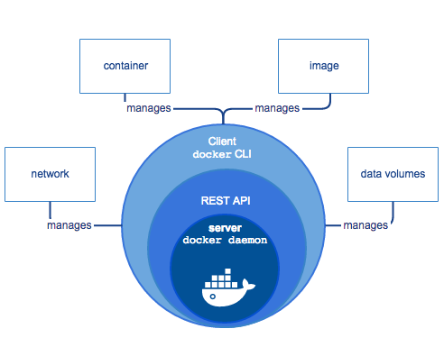
- The CLI uses the Docker REST API to control or interact with the Docker daemon through scripting or direct CLI commands. Many other Docker applications use the underlying API and CLI.
- The daemon creates and manages Docker objects, such as images, containers, networks, and data volumes.

Note: Docker is licensed under the open source Apache 2.0 license.

What is Docker’s Architecture?
- Docker uses a client-server architecture. The Docker client talks to the Docker daemon, which does the heavy lifting of building, running, and distributing your Docker containers. The Docker client and daemon can run on the same system, or you can connect a Docker client to a remote Docker daemon. The Docker client and daemon communicate using a REST API, over UNIX sockets or a network interface.

What can I use Docker for?
Fast, consistent delivery of your applications
- Docker can streamline the development lifecycle by allowing developers to work in standardized environments using local containers, which provide your applications and services. You can also integrate Docker into your continuous integration and continuous deployment (CI/CD) workflow.
- Consider the following example scenario. Your developers write code locally and share their work with their colleagues using Docker containers. They can use Docker to push their applications into a test environment and execute automated and manual tests. When developers find problems, they can fix them in the development environment and redeploy them to the test environment for testing. When testing is complete, getting the fix to the customer is as simple as pushing the updated image to the production environment.

Running more workloads on the same hardware
- Docker is lightweight and fast. It provides a viable, cost-effective alternative to hypervisor-based virtual machines, allowing you to use more of your compute capacity to achieve your business goals. This is useful in high-density environments and for small and medium deployments where you need to do more with fewer resources.

Responsive deployment and scaling
- Docker’s container-based platform allows for highly portable workloads. Docker containers can run on a developer’s local host, on physical or virtual machines in a data center, in the Cloud, or in a mixture of environments.
- Docker’s portability and lightweight nature also make it easy to dynamically manage workloads, scaling up or tearing down applications and services as business needs dictate, in near real time.

What are Docker Registries?
- A docker registry is a library of images. A registry can be public or private, and can be on the same server as the Docker daemon or Docker client, or on a totally separate server. For more details about registries, see How does a Docker registry work?
Docker registries are the distribution component of Docker.

What are Docker Images?
- A Docker image is a read-only template with instructions for creating a Docker container. For example, an image might contain an Ubuntu operating system with Apache web server and your web application installed. You can build or update images from scratch or download and use images created by others. An image may be based on, or may extend, one or more other images. A docker image is described in text file called a Dockerfile, which has a simple, well-defined syntax. For more details about images, see How does a Docker image work?
Docker images are the build component of Docker.

What are Docker Containers?
- A Docker container is a runnable instance of a Docker image. You can run, start, stop, move, or delete a container using Docker API or CLI commands. When you run a container, you can provide configuration metadata such as networking information or environment variables. Each container is an isolated and secure application platform, but can be given access to resources running in a different host or container, as well as persistent storage or databases. For more details about containers, see How does a container work?
Docker containers are the run component of Docker.

What is Docker Daemon?
- The Docker daemon runs on a host machine. The user uses the Docker client to interact with the daemon.

What is Docker Client?
- The Docker client, in the form of the docker binary, is the primary user interface to Docker.
- It accepts commands & configuration flags from the user, communicates with a Docker daemon.
- One client can even communicate with multiple unrelated daemons.

Prerequisites
- Docker requires a 64-bit OS and version 3.10 or higher of the Linux kernel.
- To check your current kernel version, open a terminal and use uname -r to display your kernel version: uname –r 3.10.0-229.el7.x86_64

Install Docker Engine:
- There are two ways to install Docker Engine. You can install using the yum package manager. Alternatively, you can use curl with the get.docker.com site. This second method runs an installation script, which also installs via the yum package manager.

Install with yum
- Log into your machine as a user with sudo or root privileges.

- Make sure your existing packages are up-to-date - #sudo yum update
- Add the yum repo –
#sudo tee /etc/yum.repos.d/docker.repo
<<-'EOF' [dockerrepo] name=Docker Repository
baseurl=https://yum.dockerproject.org/repo/main/centos/7/
enabled=1
gpgcheck=1
gpgkey=https://yum.dockerproject.org/gpg
EOF
- Install the Docker package –
#sudo yum install docker-engine
- Enable the service –
#sudo systemctl enable docker.service
- Start the Docker daemon –
#sudo systemctl start docker
- Verify docker installed correctly by running a test image in a container.
#sudo docker run --rm hello-world

Install with the script
- Log into your machine as a user with sudo or root privileges
- Make sure your existing packages are up-to-date
#sudo yum update
- Run the Docker installation script
#$ curl -fsSL https://get.docker.com/ | sh
- This script adds the docker.repo repository and installs Docker
- Enable the service
#sudo systemctl enable docker.service
- Start the Docker Daemon
#sudo systemctl start docker
- Verify docker installed correctly by running a test image in a container
#sudo docker run --rm hello-world

Uninstall:
- You can uninstall the Docker software with yum

- List the installed Docker packages.
#$ yum list installed | grep docker
#docker-engine.x86_64 1.7.1-0.1.el7@/docker-engine-1.7.1-0.1.el7.x86_64

- Remove the package
#$ yum –y remove docker-engine.x86_64
- This command does not remove images, containers, volumes, or user-created configuration files on your host.

- To delete all images, containers, and volumes, run the following command:
#$ rm –rf /var/lib/docker

- Locate and delete any user-created configuration files.

Ubuntu:
- Log into your Ubuntu installation as a user with sudo privileges.

- Update your APT package index.
#$ sudo apt-get update

- Install your APT package index.
#$ sudo apt-get install docker.io

Docker Basic Commands:
- Practical Commands:
#$ docker search imagesname
#$ docker pull imagename
#$ docker images (docker images –a)
#$ docker run –it imagename /bin/bash
#$ docker ps (ctrl+p+Q)
#$ docker ps –a (Exit)
#$ docker * login
#$ docker tag imageid newimage or tag imageid registry: 5000 or repository/imagename
#$ docker images (Check)
#$ docker rmi imagename or imageid (Remove Images)
#$ docker rmi $(docker images –q) (Delete all Images)
#$ docker rm –f containerid (Remove Containers)
#$ docker rm $(docker ps -a –q) (Remove all Containers)
#$ docker build –t anyname (Build)
#$ docker push repositoryname or registry: 5000 or repository/imagename

Before push, we want to create a repository in dockerhub
Example:
#$ docker images
#$ docker tag imageid username (dockerhub login username)/imagename
#$ docker images
#$ docker push username (dockerhub login username)/imagename
#$ login dockerhub account and check it created repository
#$ docker pull repository or registry: 5000/imagename
#$ docker images
#$ docker run –it imagename /bin/bash

Check information about Images & Containers
Example:
#$ docker info
#$ docker run –it –d imagename /bin/bash (Run Background: Detach Mode)
#$ docker ps (Check)
#$ docker attach (docker ps containerid) or docker attach containerid (Background)

Start: First, we can run background mode and after we change to attach mode above two steps now we start foreground to background.

#$ docker ps -a
#$ docker start containerid (docker ps –a id)
#$ docker ps (Check)

Stop: Stop the running container, we want to stop container (Background running) before removing that container

#$ docker stop containerid (docker ps containerid)

History: It will shows the history of image

#$ docker history imagename

Inspect: Return low-level information of container

#$ docker inspect imagename

Logs: Logs of container

#$ docker logs containerid & #$ docker logs –t containerid

Kill: Kill the running container

#$ docker ps
#$ docker kill containerid

Save: Save used to persist an Image (Not a Container). Therefore, we need image name, which we can see like, save an image to a tar archive

#$ docker images
#$ docker save imagename > newimagename.tar (or)
#$ docker save –o imagename newimagename.tar
#$ ls (Which path we created Tar Archive file)

Load: Load an image from a tar archive
#$ docker load < busybox.tar (OR)
#$ docker load -i imagename.tar (Path to image tar file)
#$ docker images

Container IP Address
#$ docker run –itd imagename bash
#$ docker ps
#$ docker exec containerid: cat /etc/hosts
Diff: Kill List the changed files & directories in a container’s filesystem. Three events that are listed in the diff.
A – Add
D – Delete
C -- Change

#$ docker run –it imagename /bin/bash
#$ mkdir xyz
#$ exit
#$ docker ps -a
#$ docker diff containerid (docker ps –a containerid)

Example:
#$ docker diff 7bb0e258aefe
C /dev
A /dev/kmsg
C /etc
A /etc/mtab
A /go
A /go/src
A /go/src/github.com
A /go/src/github.com/docker
A /go/src/github.com/docker/docker
A /go/src/github.com/docker/docker/.git
...

Export: Export used to persist a container (Not an Image). Therefore, we need containerid, which we can see like, stream the contents of a container as a tar archive

#$ docker ps -a
#$ docker export <ContainerID> > /home/export.tar (OR)
#$ docker export -output = “newname.tar” imagename
#$ ls (Check the path where we created Tar Archive file)

Import: Create a new filesystem image from the contents of tarball

#$ docker import /path/to/createdimage.tar
#$ docker images

Run Hello World: #$ docker run Ubuntu /bin/echo “Hello World”
Give Name: #$ docker run –it –-name = myname Ubuntu /bin/bash
Check Name: #$ docker ps –a

Commit: Create a new image from a container changes. It can be useful to commit a container’s file changes or settings into a new image.
#$ docker images
#$ docker run –it imagename /bin/bash
#$ mkdir xyz
#$ exit
#$ docker run –it sameimagename /bin/bash (Run Same Imagename, what we run before)
#$ ls
#$ docker ps –a
#$ docker commit <ContainerID> (docker ps –a containerid) newimagename
#$ docker images (We can run check, before created directory present or not)
#$ docker run –it newimagename (Commitedimage) /bin/bash

Volume: File sharing localhost and container

#$ docker run –it –v localhostdirectory: container imagename /bin/bash
#$ docker run –it –v /home/k/mydocker: /k container imagename /bin/bash
#$ cd /k
#$ /k# touch createfile
#$ /k# ls
#$ /k# exit

Host:
#$ cd /home/k/mydocker
#$ ls

Exec: The docker Exec command runs a new command in a running container
Usage: docker exec {options} container command [arg…]

-d, –-detach (Detached Mode run command in the background)
-i, –-interactive (Keep STDIN open even if not attached)
-p, --privileged (Give extended privileges to the command)
-t, --tty (Allocate a pseudo-TTY)

#$ docker images
#$ docker run –it imagename /bin/bash
#$ mkdir xyz
#$ exit (after exit once you run same image nothing is there, what you modified before that container)
#$ docker images (after run a particular image)
#$ docker ps –a
#$ docker restart <ContainerID> (docker ps –a containerid) (OR)
#$ docker exec –it –d containerid (docker ps –a containerid) /bin/bash
#$ docker ps
#$ docker run –it newimagename (Commitedimage) /bin/bash

Port Mapping:
#$ docker pull httpd
#$ docker images
#$ docker run –itd –P (Capital) httpd
#$ docker ps

Note: Run same command next time the port number is increasing
Firsttime run 33770:80/tcp
Secondtime run 33771:80/tcp

We assign one port
#$ docker run –itd –p (small) 8080:80 httpd
#$ docker ps
Localhost: 8080

Latest containerid using in Linux Environment show
#$ docker ps –alq

Latest created container including non-running
#$ docker ps -l

Give Volume to container:
#$ docker images
#$ docker run –it –v/xyz --name = name1 imagename /bin/bash
#$ ls
#$ exit

Note: Try same command if not working error, we can change name
#$ docker run –it –v/xyz --name = name2 imagename /bin/bash
#$ exit

Create Docker Registry:
#$ docker pull registry
#$ docker images
#$ docker run –d –p 5000:5000 registry
#$ docker images
#$ docker tag imageid (anyimageid) modifiedimage: 5000/debain: 8 (OR)
#$ docker tag imageid localhost: 5000/imagename
#$ docker push modifiedimage: 5000/debain: 8 (OR)
#$ docker push localhost: 5000/imagename
#$ docker rmi imagename
#$ docker pull imagename (localhost: 5000/imagename)

Cp: Copy Files Container to Host
#$ docker images
#$ mkdir xyz (localhost)
#$ docker run –it imagename /bin/bash
#$ mkdir xyz
#$ cd xyz
#$ xyz #mkdir abc
#$ xyz #cd abc
#$ xyz/abc #cat filename
#$ docker cp containerid: containerdirectory imagedirectory
#$ docker cp containerid: xyz/abc /xyz
Note: The file directory copy to the under /sekhar directory

Docker Management Commands
Command | Description
dockerd | Launch the Docker daemon
info | Display system-wide information
inspect | Return low-level information on a container or image
version | Show the Docker version information

Image Commands
Command | Description
build | Build an image from a Docker file
commit | Create a new image from a container’s changes
history | Show the history of an image
images | List images
import | Import the contents from a tarball to create a filesystem image
load | Load an image from a tar archive or STDIN
rmi | Remove one or more images
save | Save images to a tar archive
tag | Tag an image into a repository

Hub and Registry Commands
Command | Description
login | Register or log in to a Docker registry
logout | Log out from a Docker registry
pull | Pull an image or a repository from a Docker registry
push | Push an image or a repository to a Docker registry
search | Search the Docker Hub for images

Container Commands
Command | Description
attach | Attach to a running container
cp | Copy files/folders from a container to a HOSTDIR or to STDOUT
create | Create a new container
diff | Inspect changes on a container’s filesystem
events | Get real time events from the server
exec | Run a command in a running container
export | Export a container’s filesystem as a tar archive
kill | Kill a running container
logs | Fetch the logs of a container
pause | Pause all processes within a container
port | List port mappings or a specific mapping for the container
ps | List containers
rename | Rename a container
restart | Restart a running container
rm | Remove one or more containers
run | Run a command in a new container
start | Start one or more stopped containers
stats | Display a live stream of container(s) resource usage statistics
stop | Stop a running container
top | Display the running processes of a container
unpause | Unpause all processes within a container
update | Update configuration of one or more containers
wait | Block until a container stops, then print its exit code

More Details about DOCKER

What is Docker?
- Docker is a containerization platform that packages your application and all its dependencies together in the form of a docker container to ensure that your application works seamlessly in any environment.

What is Docker Container?
- Docker Container is a standardized unit, which can be created on the fly to deploy a particular application or environment. It could be an Ubuntu container, CentOS container, etc. to full-fill the requirement from an operating system point of view. In addition, it could be an application-oriented container like CakePHP container or a Tomcat-Ubuntu container etc.

Let us understand it with an example:
- A company needs to develop a Java Application. In order to do so the developer will setup an environment with tomcat server installed in it. Once the application is developed, it needs to be tested by the tester. Now the tester will again set up tomcat environment from the scratch to test the application. Once the application testing is done, it will be deployed on the production server. Again, the production needs an environment with tomcat installed on it, so that it can host the Java application. If you see the same tomcat environment setup is done thrice.

- There are some issues that I have listed below with this approach:
1) There is a loss of time and effort.
2) There could be a version mismatch in different setups i.e. the developer & tester may have installed tomcat 7, however the system admin installed tomcat 9 on the production server.

- Now, I will show you how Docker container can be used to prevent this loss.
In this case, the developer will create a tomcat docker image (A Docker Image is nothing but a blueprint to deploy multiple containers of the same configurations) using a base image like Ubuntu, which is already existing in Docker Hub (Docker Hub has some base docker images available for free)

- Now this image can be used by the developer, the tester and the system admin to deploy the tomcat environment. This is how docker container solves the problem.
- In case you have any further doubts, please feel to leave a comment, I will be glad to help you.
- However, now you would think that this could be done using Virtual Machines as well. However, there is catch if you choose to use virtual machine.

- Let us see a comparison between a Virtual machine and Docker Container to understand this better.

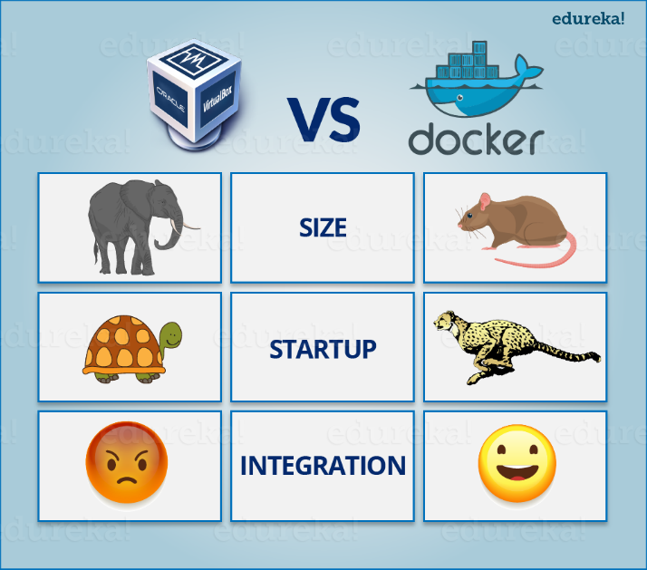

- Let me take you through the above diagram. Virtual Machine and Docker Container are compared on the following three parameters:
- Size – This parameter will compare Virtual Machine & Docker Container on their resource they utilize.
- Startup – This parameter will compare based on their boot time.
- Integration – This parameter will compare on their ability to integrate with other tools with ease.

- I will follow the above order in which parameters are listed. So first parameter would be “Size”.

What is Docker | DevOps Training | Edureka Size
- The following image explains how Virtual Machine and Docker Container utilizes the resources allocated to them.
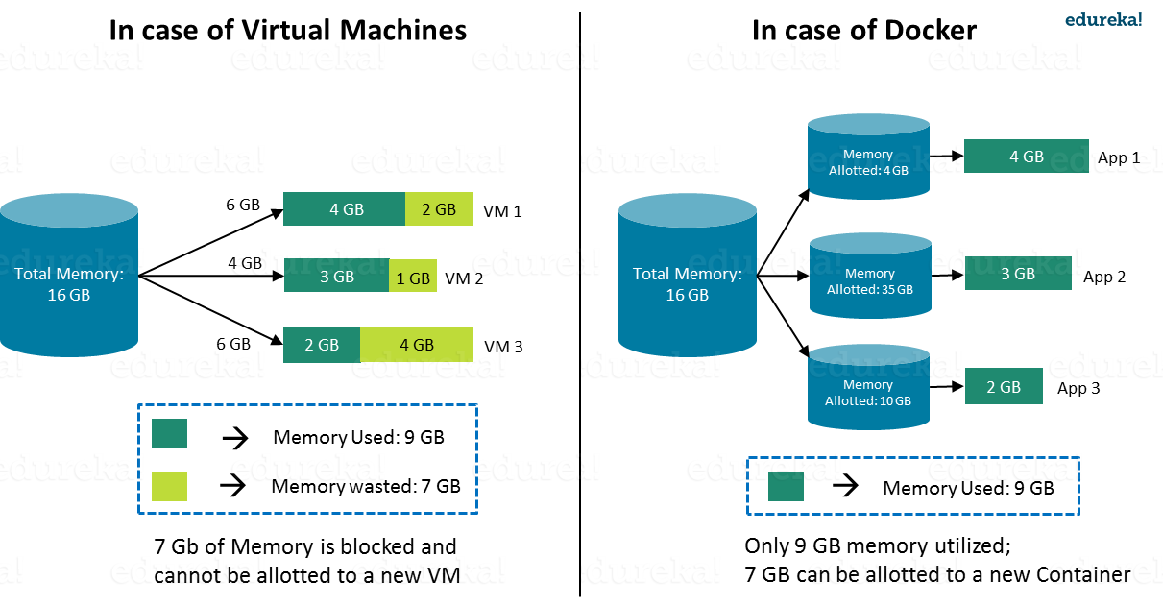
- Consider a situation depicted in the above image. I have a host system with 16 Gigabytes of RAM and I have to run 3 Virtual Machines on it. To run the Virtual Machines in parallel, I need to divide my RAM among the Virtual Machines. Suppose I allocate it in the following way:
- 6 GB of RAM to my first VM,
- 4 GB of RAM to my second VM, and
- 6 GB to my third VM.
- In this case, I will not be left with anymore RAM even though the usage is:
- My first VM uses only 4 GB of RAM – Allotted 6 GB – 2 GB Unused & Blocked
- My second VM uses only 3 GB of RAM – Allotted 4 GB – 1 GB Unused & Blocked
- My third VM uses only 2 GB of RAM – Allotted 6 GB – 4 GB Unused & Blocked

- This is because once a chunk of memory is allocated to a Virtual Machine, then that memory is blocked and cannot be re-allocated. I will be wasting 7 GB (2 GB + 1 GB + 4 GB) of RAM in total and thus cannot setup a new Virtual Machine. This is a major issue because RAM is a costly hardware.

- So, how can I avoid this problem? If I use Docker, my CPU will allocates exactly the amount of memory that is required by the Docker Container.
- My first container will use only 4 GB of RAM – Allotted 4 GB – 0 GB Unused & Blocked
- My second container will use only 3 GB of RAM – Allotted 3 GB – 0 GB Unused & Blocked
- My third container will use only 2 GB of RAM – Allotted 2 GB – 0 GB Unused & Blocked

- Since there is no allocated memory (RAM) which is unused, I save 7 GB (16 – 4 – 3 – 2) of RAM by using Docker Container. I can even create additional containers from the leftover RAM and increase my productivity. So here, Docker Container clearly wins over Virtual machine as I can efficiently use my resources as per my need.

Start-Up
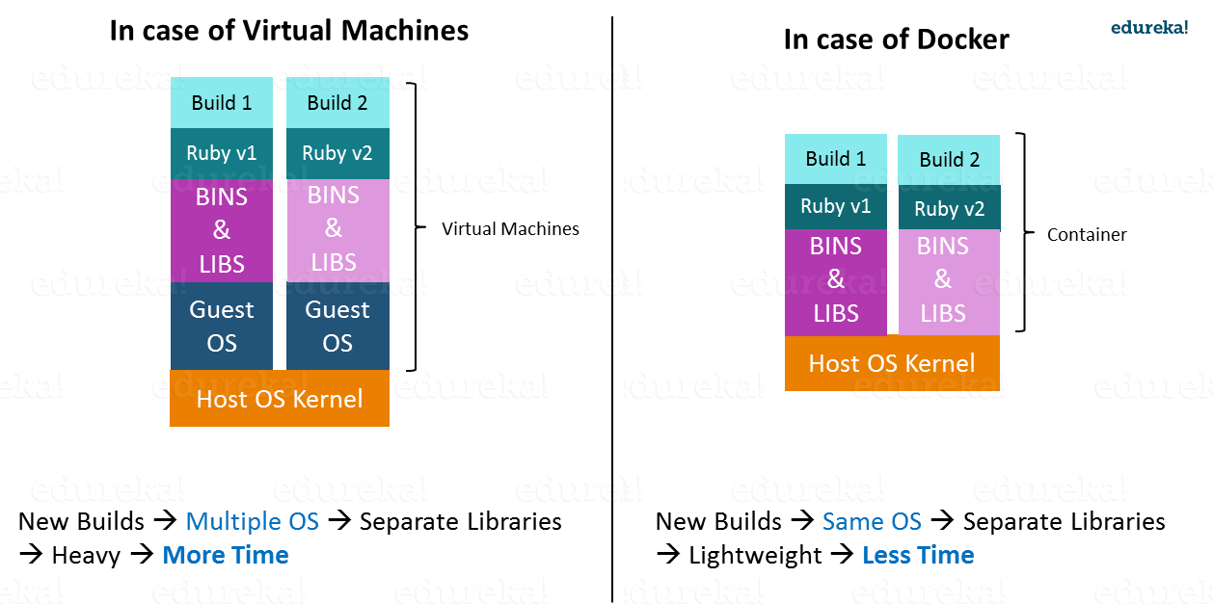
- `When it comes to start-up, Virtual Machine takes a lot of time to boot up because the guest operating system needs to start from scratch, which will then load all the binaries and libraries. This is time consuming and will prove very costly at times when quick startup of applications is needed. In case of Docker Container, since the container runs on your host OS, you can save precious boot-up time. This is a clear advantage over Virtual Machine.
- Consider a situation where I want to install two different versions of Ruby on my system. If I use Virtual Machine, I will need to set up 2 different Virtual Machines to run the different versions. Each of these will have its own set of binaries and libraries while running on different guest operating systems. Whereas if I use Docker Container, even though I will be creating 2 different containers where each container will have its own set of binaries and libraries, I will be running them on my host operating system. Running them straight on my Host operating system makes my Docker Containers lightweight and faster.
- Therefore, Docker Container clearly wins again from Virtual Machine based on Startup parameter. Now, finally let us consider the final parameter, i.e. Integration.

What about Integration?
- Integration of different tools using Virtual Machine maybe possible, but even that possibility comes with many complications.
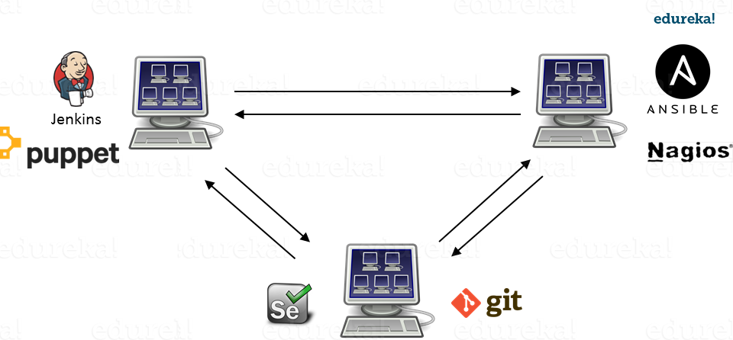
- I can have only a limited number of DevOps tools running in a Virtual Machine. As you can see in the image above, if I want many instances of Jenkins and Puppet, then I would need to spin up many Virtual Machines because each can have only one running instance of these tools. Setting up each VM brings with it, infrastructure problems. I will have the same problem if I decide to setup multiple instances of Ansible, Nagios, Selenium and Git. It will also be a hectic task to configure these tools in every VM.
- This is where Docker comes to the rescue. Using Docker Container, we can set up many instances of Jenkins, Puppet, and many more, all running in the same container or running in different containers, which can interact with one another by just running a few commands. I can also easily scale up by creating multiple copies of these containers. So configuring them will not be a problem.

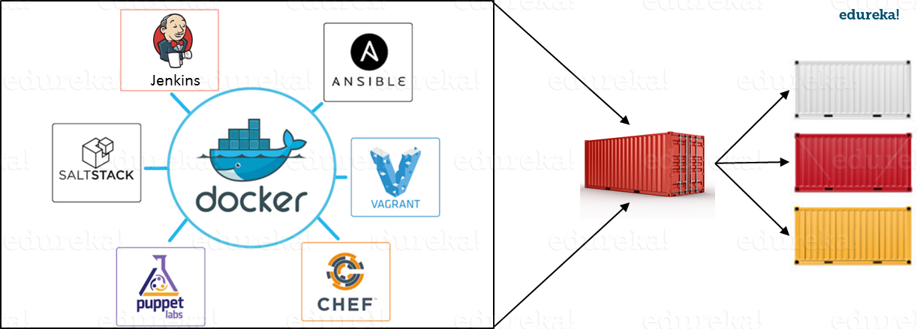

- To sum up, it will not be an understatement to say that Docker is a more sensible option when compared to Virtual Machines.
- Docker is designed to benefit both Developers and System Administrators, making it a part of many DevOps toolchains. Developers can write their code without worrying about the testing or the production environment and system administrators need not worry about infrastructure as Docker can easily scale up and scale down the number of systems for deploying on the servers.

What is Docker Engine?
- Now I will take you through Docker Engine, which is the heart of the Docker system.
- Docker Engine is simply the docker application that is installed on your host machine. It works like a client-server application, which uses:
- A server which is a type of long-running program called a daemon process
- A command line interface (CLI) client
- REST API is used for communication between the CLI client and Docker Daemon

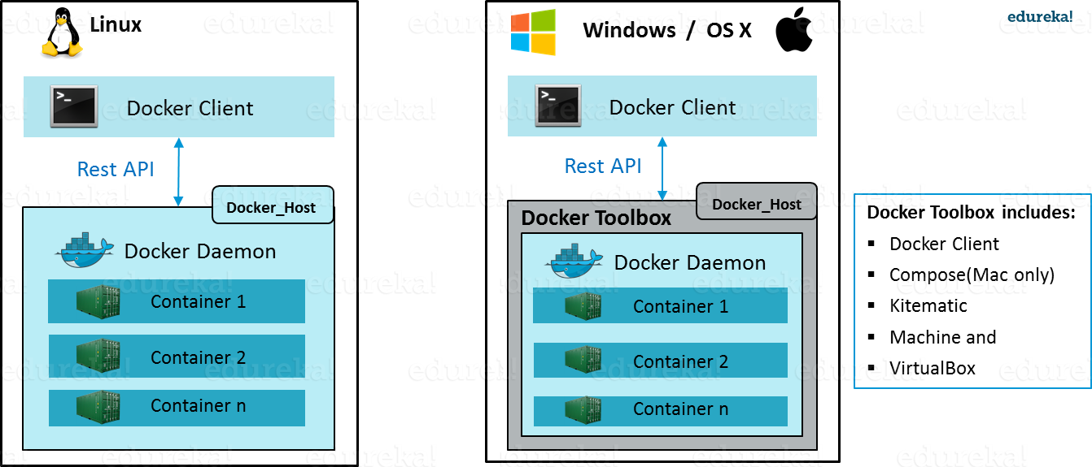
- As per the above image, in a Linux Operating system, there is a Docker client, which can be accessed from the terminal and a Docker Host, which runs the Docker Daemon. We build our Docker images and run Docker containers by passing commands from the CLI client to the Docker Daemon.
- However, in case of Windows/Mac there is an additional Docker Toolbox component inside the Docker host. This Docker Toolbox is an installer to quickly and easily install and setup a Docker environment on your Windows/iOS. Docker Toolbox installs Docker Client, Machine, Compose (Mac only), Kitematic and VirtualBox.
- Let us now understand three important terms, i.e. Docker Images, Docker Containers and Docker Registry.

What is Docker Image?
- Docker Image can be compared to a template, which is used to create Docker Containers. They are the building blocks of a Docker Container. These Docker Images are created using the build command. These Read only templates are used for creating containers by using the run command. We will explore Docker commands in depth in the “Docker Commands blog”.

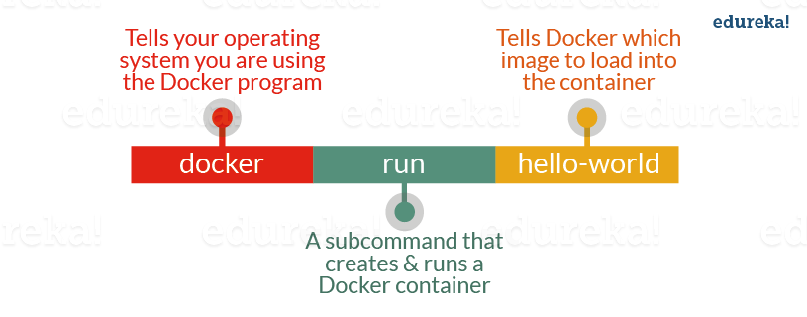
- Docker lets people (or companies) create and share software through Docker images. In addition, you do not have to worry about whether your computer can run the software in a Docker image — a Docker container can always run it.
- I can either use a ready-made docker image from docker-hub or create a new image as per my requirement. In the Docker Commands blog, we will see how to create your own image.

What is Docker Container?
- Containers are the ready applications created from Docker Images or you can say a Docker Container is a running instance of a Docker Image and they hold the entire package needed to run the application. This happens to be the ultimate utility of Docker.

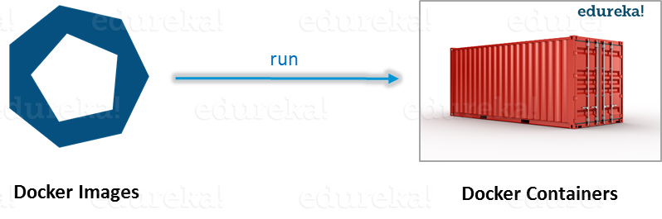

What is Docker Registry?
- Finally, Docker Registry is where the Docker Images are stored. The Registry can be either a user’s local repository or a public repository like a Docker Hub allowing multiple users to collaborate in building an application. Even with multiple teams within the same organization can exchange or share containers by uploading them to the Docker Hub. Docker Hub is Docker’s very own cloud repository similar to GitHub.

What is Docker Architecture?
- Docker Architecture includes a Docker client – used to trigger Docker commands, a Docker Host – running the Docker Daemon and a Docker Registry – storing Docker Images. The Docker Daemon running within Docker Host is responsible for the images and containers.
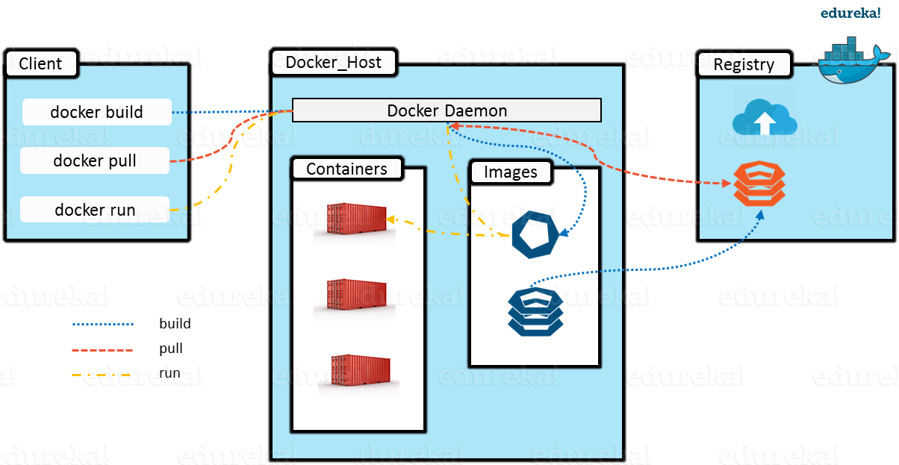

- To build a Docker Image, we can use the CLI (client) to issue a build command to the Docker Daemon (running on Docker_Host). The Docker Daemon will then build an image based on our inputs and save it in the Registry, which can be either Docker hub or a local repository.
- If we do not want to create an image, then we can just pull an image from the Docker hub, which would have been built by a different user.
- Finally, if we have to create a running instance of my Docker image, we can issue a run command from the CLI, which will create a Docker Container.

